MS-Azure

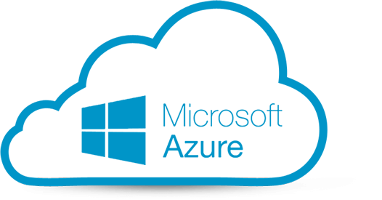

### Introduction

* Introduction to cloud
* Various cloud providers
* Why Azure
* Azure vs AWS vs GCP
* Types of cloud models
* Types of cloud services
* Azure subscription types
* Regions and availability zones in Azure
* Setup Azure CLI

### Compute

**Virtual machine**

* Create a New virtual machine
* Select the right Image, size
* Setup inbound and outbound ports
* Attach type of volume
* Select a network public and private
* Setup subnet
* Create security groups
* Setup keys and credentials

**Disk**

* Understand volume type
* Volume creation
* Attach, detach
* Volume management

**Image**

* Vm backup
* Create vms using images
* Cross region access

**Snapshots(Backups)**

* Disk backup
* Attach to vms
* Access across regions

**Virtual machine scale sets**

* Auto scale vms
* Create scale set to auto in and out

**Availability sets**

* Maintain redundancy
* High availability

**Container Instances**

* Create Docker containers vms
* Setup security
* Port mapping
* Deploy Docker containers on vms

### Networking

**Virtual Networks**

* Subnets
* Ip ranges
* Routing
* VNET peering
* Security groups
* Access control list
* Public subnets
* Private subnets
* Gateways
* Public IP address

**CDN Profiles**

* origin type
* origin URL
* custom links
* Filters
* Cache

**Load balancers**

* Type of load balancers
* Attach & Detach Subnets
* Security groups for the load balancer
* Load balancing protocols
* SSL Negotiation Configurations
* Configure health check for the load balancer
* Listener Configurations
* Adding instance to groups
* Outbound rules
* Load balancer metrics
* Routing
* High availability ports

**Traffic Manager**

* Introduction
* Routing Methods
* Profile types
* Recovery

### Storage & Databases

**Azure storage accounts**

* Introduction
* Storage account types
* Blob Storage
* Block Blobs
* Page Blobs
* File Storage
* Table Storage
* Queue Storage
* Access Tiers
* Data Redundancy
* Performance & Scaling
* Event Handling
* Page Blobs

**Azure SQL**

* Introduction
* Create database
* Remote access
* Service tiers

**Azure MySql**

* Overview
* Resources
* Databases and servers
* Backup, Restore

**Azure Cosmos DB**

* Introduction
* Global distribution
* Mongo DB API
* Cassandra DB API

**Azure Redis Cache**

* Overview
* Scheduled updates
* Data import and export
* replications

### Containers & Kuberenetes

**Container(Docker) Instances**

* Create Docker containers vms
* Setup security
* Port mapping
* Deploy Docker containers on vms

**Kubernetes services**

* Create and deploy clusters
* Cluster operation
* Creating, scaling, upgrading

### Identity & Security

**Azure Active Directroy**

* Introduction to Azure Active Directory
* AAD architecture
* Access management
* User management
* Group management
* Authentication
* Privileges
* Roles

**User**

* create users
* add user to groups
* assign permission

**Group**

* Create groups
* Manger users
* Mange Previlages

**Azure AD B2C**

* What is B2C
* Types
* Authentication

**Azure AD B2B**

* B2B user access
* B2C vs B2B
* Access control & licensing

### Azure DevOps

* Version control
* Continuous integration
* Continuous Delivery
* CI/CD pipeline

### Monitor

**Monitor**

* Overview
* Log and Query Analytics
* Graphical log creation
* Setup alert, notifications
* Continuous Monitor
* Application insights
* Metrics